|  |
| --- |
| Colour.png |
| Planning Proposal No 3 |
|  |
|  |
|  |
| **This planning proposal has been prepared to rezone 69 Hardinge Street from R1 General Residential to B2 Local Centre to permit the development of the land for commercial purposes and to rezone Lot 12 DP1105250 Decimus Street from RE1 Public Recreation to R1 General Residential to correct a zoning error.** |

**1 OBJECTIVES OR INTENDED OUTCOMES**

The objective of this planning proposal is to permit the development of 69 Hardinge Street for commercial purposes and to correct a zoning anomaly for land located in Decimus Street.

**2 SUBJECT SITES**

**69 Hardinge Street**

This property consists of 4 lots known as Lots 1-3 DP585942 and Lot 2 DP383553 and has a total area of approximately 2360m2. It has frontage to both Poictiers and Hardinge Streets and Hardinge Street is a classified main road. The site is currently vacant but Lot 2 DP383553 was previously occupied by a shed (has been demolished) and Lots 1-3 DP585942 was occupied by three lowset terrace houses which by the time of their demolition (2007/2008) were in poor condition There is no vegetation on the site. Figure 1 contains a map showing the location of the site.

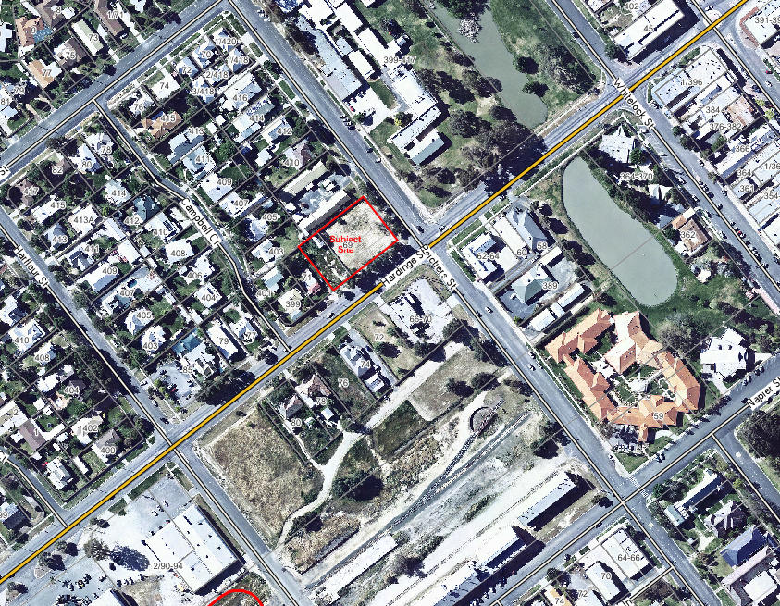

**Figure 1 Location of 69 Hardinge Street**

The subject site is currently zoned R1 General Residential and it is proposed to rezone it to B2 Local Centre. The general area is one of mixed use. Whilst the immediate adjoining land is zoned R1 General Residential, land to the east is zoned B2 Local Centre. Figure 2 shows the zoning of the surrounding land and indicates current land uses.

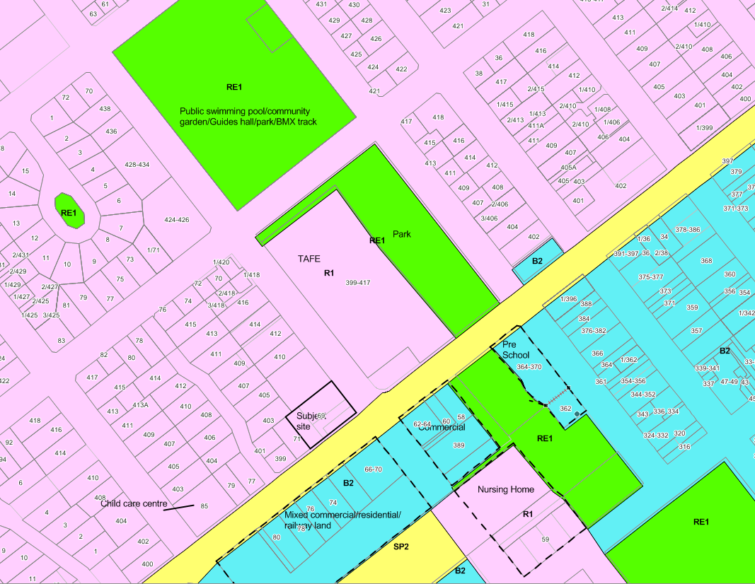

**Figure 2 Zoning map and existing land uses**

Since the demolition of the buildings on the site Council has conducted a number of pre DA meetings for the use of the land. The majority of these meetings have been about establishing commercial uses on the site.

Council has now been approached by the owner of the land to rezone the land to B2 Local Centre. The rezoning of this land would allow for a commercial use to be established. The owner has identified that given the size and location of the land that it would be suitable for use as bulky goods premises. The site has frontage to a main road and a second frontage to a local road and the size of the land would allow for the construction of custom designed premises for this type of use.

**Decimus Street**

Lot 12 DP1105250 Decimus Street is currently zoned RE1 Public Recreation and is in private ownership. The subject site has an area of approximately 884m2. Figure 3 shows the location of the subject site and the zoning and Figure 4 provides an aerial view of the site. The subject site is located between two parcels of land. Land to the south west is zoned RE1 Public Recreation and is known as Crown Reserve 88943 under the care and management of Council and is reserved for public recreation. The adjoining lot (Lot 26 DP845007 Decimus Street) to the north east is zoned R1 General Residential. This lot along with the subject site are in the same private ownership.

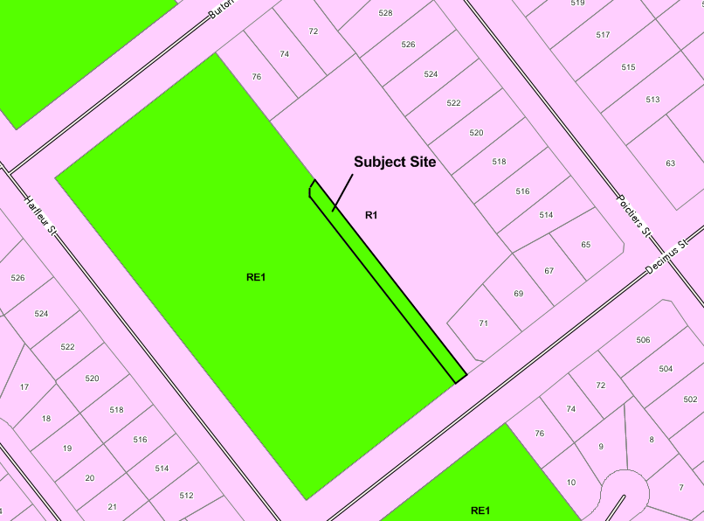

**Figure 3 Existing Zoning – Decimus Street**

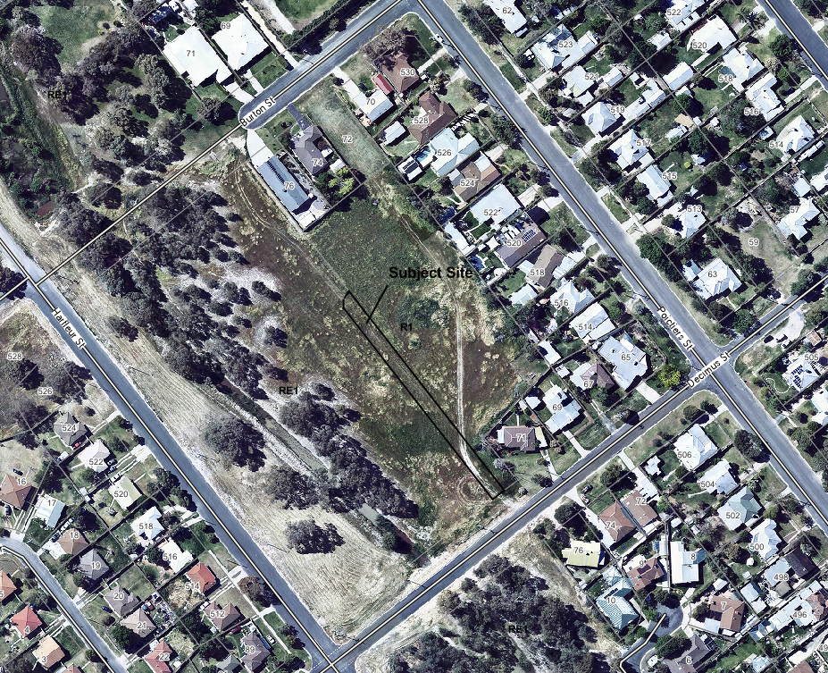

**Figure 4 Aerial View – Decimus Street**

A development application has been lodged with Council for a 7 lot subdivision of Lot 26 DP845007 Decimus Street and it is proposed to construct a road to access the subdivision on Lot 12 DP1105250. It is at this point that this zoning anomaly became apparent. Whilst roads are permissible with consent in the RE1 Public Recreation zone, it is preferable that given that the land is in private ownership that it be zoned R1 General Residential.

**PART 3 EXPLANATION OF PROVISIONS**

The proposed outcome will be achieved by:

* **69 Hardinge Street** – amending Land Zoning Map Sheet 5 of the Deniliquin Local Environmental Plan 2013 by changing the zone from R1 General Residential to B2 Local Centre.
* **Decimus Street** – amending Land Zoning Map Sheet 5 of the Deniliquin Local Environmental Plan 2013 by changing the zone from RE1 Public Recreation to R1 General Residential.

**PART 4 JUSTIFICATION**

**69 Hardinge Street**

The owner of the land has requested that Council rezone this land from R1 General Residential to B2 Local Centre. The purpose of the rezoning would allow the land to be developed for commercial purposes that are permissible within the B2 zone. In particular, it is intended to construct two buildings each with floor area for office/showroom/retailing and an attached warehouse. Whilst the buildings could be adapted for a variety of uses that are permissible in the B2 zone, the owner has specifically identified that the buildings would be suitable to be used as bulky goods premises. The buildings would provide a large area for the handling, display or storage of goods and as the site has a dual road frontage, direct vehicular access to the site for purpose of loading or unloading goods into or from vehicles after purchase or hire could be readily achieved. The owner of the land has also identified the difficulty in obtaining greenfield sites zoned B2 in Deniliquin.

***Available B2 Land***

Council has undertaken a desk top analysis of land zoned B2 under LEP 2013 and determined that there is 24.3ha zoned B2 and only 2.6ha of this land is vacant. This 2.6ha consisting of nine parcels of land:

* 116-118 Hardinge Street – 4873m2 that is not available for development;
* Railway land, Hardinge Street – 1.4ha that is being handed back to the NSW State Government which Council will then seek to acquire for seniors housing;
* 72 Hardinge Street – area of 1028m2. This is not available for development and would not have sufficient area for the proposed development.
* 76 Hardinge Street – area of 1078m2. This is not available for development and would not have sufficient area for the proposed development.
* 89 End Street – area of 1012m2. Owned by Deniliquin RSL and not available for development.
* 73-81 End Street – consists of 4 lots with a total area of 4048m2. Owned by Deniliquin RSL. Would have sufficient area for the development but is not available for development.

Council is aware that there are limited greenfield sites available for development in the B2 zone and in particular with main road frontage. The availability of greenfield sites across the whole of the B2 zone has been a recurring issue for some time and this is evident to Council through the pre DA meetings held with potential applicants looking to establish themselves in the CBD.

***Impact of R1 Land***

In addition to this, Council has adequate greenfield residential land available for development. Council estimates that it has in excess of 120ha in greenfield sites and this site represents a loss of less than 1% of the total greenfield residential land available in Deniliquin.

***Location of Site***

The subject site is located in an area of mixed use and is within close proximity to the existing B2 zone. Figure 2 shows the types of uses occurring within the immediate vicinity of the site. Within a 100m radius of the site there are a number of commercial uses occurring including two childcare centres, real estate office, offices of the Deniliquin Ute Muster, vet clinic, town band hall, auto parts retailer, Riverina TAFE and a carpet and curtains retailer.

***Site Suitability***

The subject site is highly suitable for commercial uses. The size of the subject site and the fact that it is vacant means that the buildings can be constructed that are purpose built for the future use in a desirable location (ie main road frontage). This site has main road frontage and a second frontage to a local road. This double frontage will allow for better access to the site, ensures that vehicles will enter and exit the site in a forward direction, limits the number of driveways required on a main road and overall allows for more efficient vehicle and site management.

***Impact on Adjoining Uses***

There is a dwelling on the south west boundary and units on north west boundary. The dwelling is offset from the common boundary by 5.2m and the units are offset by 3.5m. The developer is proposing to offset the proposed building 9m from the south west boundary. This setback is to accommodate an ‘exit only’ driveway and to ensure adequate distance from a sewer main which is approximately 6.8m from this boundary. On the north west boundary, the proposed building will be setback 8m to accommodate an ‘entry only’ driveway off Poictiers Street. The proposed layout of the buildings on the site will minimise any impacts on the adjoining residential properties. Whilst consideration is only being given at this stage to the rezoning, a future DA for the site will give Council the opportunity to undertake a full assessment of the potential impacts.

***Zoning Mechanism***

Council has given consideration to either retaining the current zone and inserting an additional use into Schedule 1 for this site or making bulky goods premises permissible in the R1 zone so that they would be permissible throughout that zone. The use of Schedule 1 would be inconsistent with Section 117 Direction Site Specific Provisions and inserting bulky goods premises into the R1 zone as a permissible use would make this use available to R1 land in Deniliquin and would potentially long term undermine the existing B2 zone. Council considers that rezoning the land to B2 to be the best mechanism for achieving the proposed outcome and ensures that if the development did occur that the development will be viable given that the buildings will be purpose built and that a range of commercial uses would be available to the site.

***Davidson Street/B6 Land***

In the deferred area under LEP 2013, Council has land that is zoned 2(Urban) under LEP 1997. This land is predominantly used for residential/commercial/light industrial uses eg car dealerships, service station, rural supplies, cabinet maker, food and drink premises, dwellings etc. This land is located within a floodway (identified in the Edward River at Deniliquin Flood Study (2014)) and there is currently no vacant land available in this area. There is also a small area of B6 land in North Deniliquin with one vacant parcel of land with an area of 1050m2. Whilst some of this land has frontage to a classified main road this land is not as desirable as land in South Deniliquin.

**Decimus Street**

This land is zoned RE1 Public Recreation but is in private ownership and as such is not available for public recreation. Council has no interest or plans in acquiring the land for public recreation. The owner of the land has lodged a development application for the subdivision of an adjoining lot and is proposing to construct a road over the subject lot. Whilst roads are permissible with consent in the RE1 Public Recreation zone, the zoning should be changed to reflect the adjoining zones.

*Is the planning proposal a result of any strategic study or report?*

The planning proposal is not the result of any strategic study or report.

*Is the planning proposal the best means of achieving the objectives or intended outcomes, or is there a better way?*

**69 Hardinge Street**

A planning proposal is the best means of achieving the objectives or intended outcomes. The R1 General Residential zone only provides for a limited amount of commercial uses in the zone. Council has provided justification above for the proposed rezoning.

**Decimus Street**

The subject site could retain the RE1 zone and it is unlikely that there would be significant consequences as a result of this. However, given that the land will form part of a residential subdivision, it is privately owned and Council has no interest in acquiring the land for a public reserve, rezoning the land will correct this anomaly.

*Is the planning proposal consistent with the objectives and actions of the applicable regional or sub-regional strategy?*

There is no regional or sub-regional strategy for the Deniliquin Local Government area.

*Is the planning proposal consistent with a council local strategy or other local strategic plan?*

Deniliquin Council does not have a local strategy or other local strategic plan.

*Is the planning proposal consistent with the applicable State Environmental Planning Policies?*

No. All SEPPs are considered in Appendix 1.

*Is the planning proposal consistent with applicable Ministerial Directions (s117 directions)?*

No. All S117 directions are considered in Appendix 2.

*Is there any likelihood that critical habitat or threatened species, populations or ecological communities, or their habitats, will be adversely affected as a result of the proposal?*

No.

*Are there any other likely environmental effects as a result of the planning proposal and how are they proposed to be managed?*

***Hardinge Street***

There are unlikely to be any other likely environmental effects resulting from this planning proposal. The land is within an established urban area, is currently vacant and no environmental issues are evident from the assessment of this rezoning.

***Decimus Street***

No. This part of the planning proposal is to correct a zoning anomaly.

*Has the planning proposal adequately addressed any social and economic effects?*

***Hardinge Street***

Yes. Justification of the rezoning has been provided. Council does not envisage any significant detrimental social and/or economics impacts from the rezoning.

***Decimus Street***

Not applicable. This part of the planning proposal is to correct a zoning anomaly.

*Is there adequate public infrastructure for the planning proposal?*

No.

*What are the views of state and Commonwealth public authorities consulted in accordance with the Gateway determination?*

Council has not consulted any state and Commonwealth public authorities in preparing this planning proposal. Council proposes to consult with the Road and Maritime Services regarding 69 Hardinge Street.

**PART 5 MAPPING**

Figure 5 shows the change of zone for 69 Hardinge Street. Figure 6 shows the change of zone for Decimus Street.

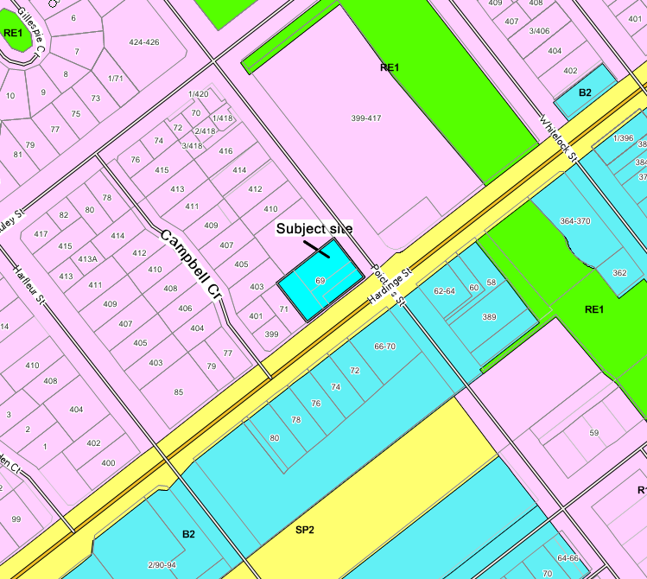

**Figure 5 Proposed B2 Zone – 69 Hardinge Street**

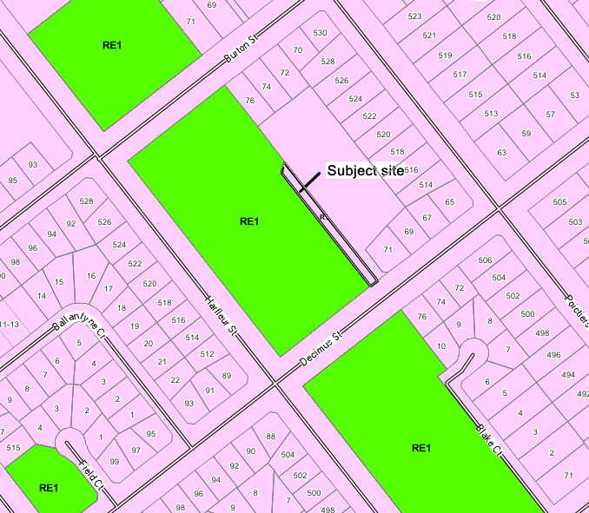

**Figure 6 Proposed R1 Zone – Decimus Street**

**PART 6 COMMUNITY CONSULTATION**

In accordance with section 57 of the Environmental Planning and Assessment Act, it is proposed to exhibit the planning proposal for 14 days in the local media and on Council’s website, a sign will be placed on both sites and letters will be sent to adjoining owners.

**PART 7 PROJECT TIMELINE**

Given the nature of the amendment, Council proposes to complete the amendment in 6 months.

|  |
| --- |
| Colour.png |
| Appendix 1 |
|  |
|  |
|  |
| **Consideration of State Environmental Planning Policies** |

|  |  |  |
| --- | --- | --- |
| **SEPPs** | **Consistent** | **Comments** |
| SEPP 21 Caravan Parks | n/a | - |
| SEPP 30 Intensive Agriculture | n/a | - |
| SEPP 32 Urban Consolidation (Redevelopment of Urban Land) | No  Yes | This SEPP applies to all urban land in NSW and as such applies to this proposal. Cl 6 requires Council to consider whether urban is no longer needed or used for the purposes for which it is currently zoned or used, whether it is suitable for redevelopment for multi-unit housing and related development in accordance with the aims and objectives of this SEPP and whether action should be taken to make the land available for such redevelopment.  ***Hardinge Street***  Under the current zoning of the land multi dwelling housing is permissible with consent. Should the land be rezoned to B2 Local Centre then multi dwelling housing will be prohibited in the zone. This means that the proposed rezoning is inconsistent with this SEPP.  The proposed inconsistency is considered to be justified as there is in excess of 120ha of land zoned R1 General Residential and multi dwelling housing is permissible with consent in the R1 zone.  ***Decimus Street***  The rezoning of this land to R1 General Residential will mean additional land will be available for multi dwelling housing. |
| SEPP 33 Hazardous and Offensive Development | n/a | - |
| SEPP 36 Manufactured Home Estates | Yes | Clause 6 of the SEPP states that a manufactured home estate may be carried on land on which a caravan parks is permissible with consent.  ***Hardinge Street***  A caravan park is currently permissible with consent in the R1 General Residential zone and will be permissible with consent in the B2 Local Centre should the rezoning proceed. This means that the permissibility of manufactured home estates will not be affected by the rezoning of this site.  ***Decimus Street***  Under the current zoning, a caravan park is prohibited in the RE1 Public Recreation zone and as such, a manufactured home estate would also be prohibited. However, the rezoning of this land to R1 General Residential will mean that caravan parks will be permissible with consent as will manufactured home estates.  The planning proposal is considered to be consistent with this SEPP as the rezoning will mean that manufactured home estates will be permissible with consent on both of the subject sites. |
| SEPP 50 Canal Estate Development | n/a | - |
| SEPP 52 Farm Dams and Other Works in Land and Water Management Plan Areas | n/a | - |
| SEPP 55 Remediation of Land | Yes | Council is required to considered cl6 of this SEPP where a rezoning is proposed.  ***Hardinge Street***  The property history for this site does not indicate that a use referred to in Table 1 of the contaminated land planning guidelines has been carried out on this site. Whilst the uses listed in clause 6(4) of the SEPP are permissible with consent in the zone, the owner of the land has not indicated an intention to develop the land for any of these purposes.  ***Decimus Street***  The property history for this site does not indicate that a use referred to in Table 1 of the contaminated land planning guidelines has been carried out on this site. Whilst the uses listed in clause 6(4) of the SEPP are permissible with consent in the zone, a development application has been lodged for this lot and the adjoining lot (Lot 26 DP845007) for a residential subdivision and it is proposed to construct a road over the subject site. Given that there is no evidence of any potential contamination and that it is proposed to erect a road over the land, no further investigation of this land is required. |
| SEPP 62 Sustainable Aquaculture | No | ***Hardinge Street***  Clause 7 of the SEPP states that pond based and/or tank based aquaculture (being small scale aquarium fish production) is permissible in the R1 General Residential zone subject to the requirements of Schedule 1 of the SEPP. Under the B2 Local Centre zone, the pond based aquaculture will be prohibited but tank based aquaculture will be permissible. This means that there will be a reduction of 2360m2 of land available for pond based aquaculture in Deniliquin. However, this reduction in land available for this use is considered insignificant due to the amount of land (when considering cl 7) that will remain available ie the use will remain permissible in the RU1, R5, SP2, RE1, RE2, E3, W1 and W2 zones.  ***Decimus Street***  Clause 7 of the SEPP states that pond based and/or tank based aquaculture is permissible in the RE1 Public Recreation zone subject to the requirements of the Schedule 1 of the SEPP. Under the R1 zone these uses will continue to be permissible but only where it is for the purpose of small scale aquarium fish production. Therefore the change of use will limit the range of pond based and/or tank based aquaculture that is permissible on this land. However this reduction in land available for this use is considered to insignificant due to the amount of land (when considering cl 7) that will remain available ie the use will remain permissible in the RU1, R5, SP2, RE1, RE2, E3, W1 and W2 zones. |
| SEPP 64 Advertising and Signage | Yes | ***Hardinge Street***  Clause 10 of this SEPP prohibits the display of an advertisement on residential land other than those signs which are listed in clause 9 of the SEPP. The rezoning of this land to B2 would mean that subject to assessment that signs identified under part 3 of the SEPP would be permissible in the zone.  ***Decimus Street***  Clause 10 of this SEPP prohibits the display of an advertisement on open space land other than those signs which are listed in clause 9 of the SEPP. This would not change with the rezoning of the land to R1. |
| SEPP 65 Design Quality of Residential Flat Development | n/a  Yes | ***Hardinge Street***  Residential flat buildings are permissible in the R1 zone and as such this SEPP applies to this land. However, the proposed rezoning would mean that residential flat buildings will be prohibited in the B2 zone. This SEPP is not considered applicable to the rezoning because the SEPP aims to improve the quality of residential flat building design.  ***Decimus Street***  Residential flat buildings are prohibited in the RE1 zone. However, the proposed rezoning would mean that residential flat buildings will be permissible in the R1 zone. If a residential flat building is proposed for this land then this SEPP would apply. |
| SEPP 70 (Affordable Rental Housing) 2009 | No  Yes | ***Hardinge Street***  The proposed rezoning will impact on the amount of land that is available for certain development under this SEPP. However, as previously stated Deniliquin has in excess of 120ha of undeveloped residential land available and this rezoning will result in a reduction of this by 2360m2. This reduction in land is not considered significant and in particular given that since this SEPP was gazetted in 2009 it has not been applied in Deniliquin.  ***Decimus Street***  The proposed rezoning will mean that additional land would be available for development under this SEPP. |
| SEPP (Building Sustainability Index: BASIX) 2004 | No  Yes | ***Hardinge Street***  The application of this SEPP to dwellings will not change with the proposed rezoning as dwellings are permissible in both the R1 and B2 zones. However the provisions will not apply to development where there is more than one dwelling as these types of dwellings are not permissible in the zone. However this inconsistency is not considered to be significant given that it is likely that Part J of the BCA will apply to any redevelopment of this land.  ***Decimus Street***  Residential development will be permissible on this land should the rezoning proceed and it is likely that this SEPP would apply to this land. |
| SEPP (Exempt and Complying Development Codes) 2008 | n/a | This planning proposal will not affect the operation of this SEPP in relation to the subject sites. |
| SEPP (Housing for Seniors or People with a Disability) 2004 | Yes | ***Hardinge Street***  This SEPP applies to land that zoned primarily for urban purposes and where certain development is permitted on that land. It is considered that B2 land is land zoned primarily for urban purposes and as such the rezoning would be consistent with this SEPP.  ***Decimus Street***  The rezoning of this land to R1 would mean that the land is zoned primarily for urban purposes and as such would increase the amount of land available for this type of development. |
| SEPP (Infrastructure) 2007 | n/a | This planning proposal will not affect the operation of this SEPP in relation to the subject sites. |
| SEPP (Major Development) 2005 | n/a |  |
| SEPP (Mining, Petroleum Production and Extractive Industries) 2007 | n/a | The permissibility or prohibition of the uses identified under the SEPP and their application to the subject site will not change as a result of this planning proposal. |
| SEPP (Miscellaneous Consent Provisions) 2007 | n/a | This planning proposal will not affect the operation of this SEPP in relation to the subject sites. |
| SEPP (Rural Lands) 2008 | n/a |  |
| SEPP (State and Regional Development) 2011 | n/a | This planning proposal will not affect the operation of this SEPP in relation to the subject sites. |

|  |
| --- |
| Colour.png |
| Appendix 2 |
|  |
|  |
|  |
| **Consideration of Section 117 Directions** |

|  |  |  |
| --- | --- | --- |
| **Section 117 Direction** | **Consistent** | **Comments** |
| 1.1 Business and Industrial Zones | Yes  n/a | ***Hardinge Street***  The planning proposal is consistent with this s117 direction as it proposes to increase the area of land available for business uses by 2360m2. It is consistent with the objectives of the direction as it is not reducing the amount of land for business uses and the location of the land does not undermine the viability of the existing CBD as it is located within the vicinity of the existing CBD and in an area of mixed use.  ***Decimus Street***  n/a |
| 1.2 Rural Zones | - | - |
| 1.3 Mining, Petroleum Production and Extractive Industries | - | The planning proposal will not result in the prohibition of the uses specified in clause 3(a) or restrict the potential development of resources specified in clause 3(b). |
| 1.5 Rural Lands | - | *-* |
| 2.1 Environment Protection Zones | n/a | - |
| 2.3 Heritage Conservation | n/a | The LEP 2013 already has clauses relating to heritage conservation. |
| 2.4 Recreation Vehicle Areas | n/a | - |
| 3.1 Residential Zones | No  Yes | ***Hardinge Street***  In terms of Hardinge Street, the planning proposal will reduce the amount of land zoned R1 by 2360m2. This reduction in land zoned R1 is of minor significance as Council estimates that it has in excess of 120ha available for development in this zone. The subject site represents less than 1% of the area of R1 land available in Deniliquin.  ***Decimus Street***  In terms of Decimus Street, there will be an increase of land zoned R1 of 884m2. This is consistent with this direction. |
| 3.2 Caravan Parks and Manufactured Homes Estates | Yes | ***Hardinge Street***  A caravan park is currently permissible with consent in the R1 General Residential zone and will be permissible with consent in the B2 Local Centre should the rezoning proceed. As a caravan park is permissible in a B2 zone, manufactured home estates will also be permissible on this land in accordance with SEPP 36.  ***Decimus Street***  Under the current zoning, a caravan park is prohibited in the RE1 Public Recreation zone and as such, a manufactured home estate would also be prohibited. However, the rezoning of this land to R1 General Residential will mean that caravan parks will be permissible with consent as will manufactured home estates (under SEPP 36).  The planning proposal is consistent with this direction. |
| 3.3 Home Occupations | n/a | This planning proposal does not affect the permissibility of home occupations in zones where dwellings are permissible. |
| 3.4 Integrating Land Use and Transport | n/a | This direction is not considered applicable to this planning proposal as it is not proposed to open up large greenfield sites for development. The rezoning of these sites will not increase the need for public transport, the reliance on private transport is high regardless of these rezonings occurring and the rezonings will not affect the movement of freight. |
| 3.5 Development Near Licensed Aerodromes | No | All land within the Deniliquin urban area is within the vicinity of a licensed aerodrome and regardless of whether this planning proposal proceeds, the impact on the subject sites will not change. Council has a clause in the LEP which deals with airspace operations and any such impacts can be determined through the assessment of development applications. |
| 3.6 Shooting Ranges | n/a | - |
| 4.3 Flood Prone Land | n/a | - |
| 4.4 Planning for Bushfire Protection | n/a | - |
| 6.1 Approval and Referral Requirements | n/a | - |
| 6.2 Reserving Land for Public Purposes | n/a | The land at Decimus Street is zoned RE1 Public Recreation but the land is in private ownership. The land has not been identified by Council for acquisition. |
| 6.3 Site Specific Provisions | Yes | Council considered amending Schedule 1 of LEP 2013 to permit development of the Hardinge Street site for a specific purpose (ie bulky goods premises). Given that this would have been inconsistent with this direction, Council has determined to rezone the land B2 Local Centre to permit a range of commercial uses. This is consistent with this direction. |